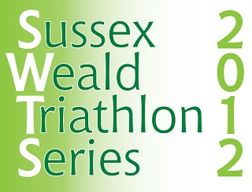
Four Great Sprint Triathlon Races across the heart of Mid Sussex
Congratulations!
As a competitor in the Mid Sussex Triathlon with a Mid Sussex District Council postcode you are already part of the way towards qualifying for entry to the Sussex Weald Triathlon Series!
So now is the time to finish off the process by entering two more of the other races in the Series………..
Series Qualifying Races
Haywards Heath Triathlon Sunday 29th April  www.hedgehogtri.co.uk | East Grinstead Triathlon Sunday 13th May  www.egtri.com
Ardingly Triathlon Sunday 3rd June  www.hedgehogtri.co.uk | Mid Sussex Triathlon Sunday 10th June  www.midsussextriathlonclub.com

How to take part in the Series
- Enter and complete a minimum of three of the Qualifying Races
- Automatic Series entry with MSDC postcode – no additional entry fee or forms
Competition Rules
- A minimum of three races must be completed
- Points will be awarded in each BTF Age Group as follows; 1 point for 1st place, 2 points for 2nd place, 3 points for 3rd place etc.
- The Winners (male and female) will be the ones with the lowest number of points over a minimum of three Races
- In the event of a tie, the winner will be either the person judged to have the best result in a fourth qualifying Race or to have competed in the Age Group section with the greatest number of entrants
- The decision of the Judges will be final and binding on all competitors – Judges to be drawn from Event Organisers
Prizes
- 1st Prize Male/Female – a year’s free membership of Freedom Leisure gym
- Winners to be announced and presented at Mid Sussex Triathlon on Sunday 10th June

